
Selection Table 1: Financial Document Shredding Solutions v2024.9.21
️ Destruction Targe: Accounting vouchers, file archives, R&D drawings, bids, books
 | Plan1: YD- FSJQL600 | Plan2: YD-PSJ300 | Plan3: YD-PSJ300ES | Plan4: YD-310CC | Plan5: YD-PSJ350 | Plan6: YD-FSJQL Series | Plan7: YD-FSJPC300
Pricing USD | $4,435 | $5,600 | $2,817 | $2,655 | $14,073 | L300: $1,660  L400: $2,160  L500: $2,797 | $979
Full  Image | 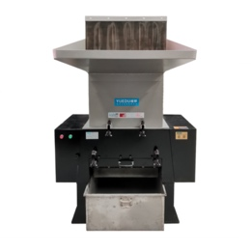 | 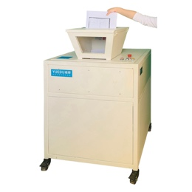 | 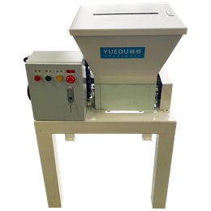 | 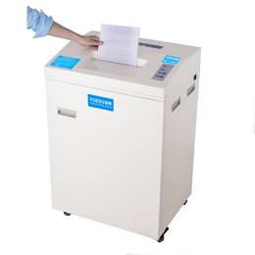 | 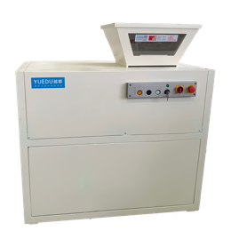 | 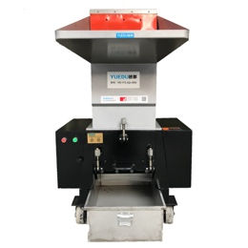 | 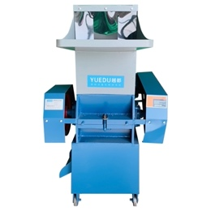
Vouchers  Entry Image | 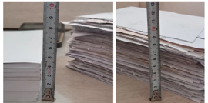 | 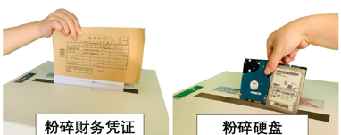 |  | 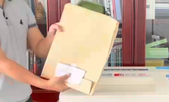 | 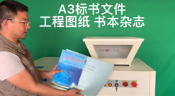 | 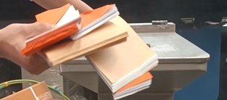 | 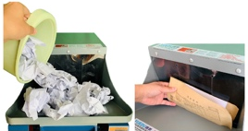
Features | 3cm thick vouchers,  8cm file archives,  shred 500 sheets at once. | Sleek design, capable of shredding hard drives. | Shreds 1-2 tons per day, mobile with wheels, suitable for on-site destruction. | 40-60 KG per hour  no noise or dust, mobile with wheels. | Sleek design, suitable for government use, shreds 2-4 tons per day. | Noise and dust might be noticeable; destroy vouchers and bids without disassembly. | Higher noise and dust, slower speed, affordable.
Applicable Scenarios | thick financial vouchers and large quantities of bids and files. | Industry leaders, multinational companies, government, and military. | small business destruction, medium-sized enterprise destruction | Suitable for placement near office printers, where only 220V power is available. | Industry leader  Multinational  Pharmaceutical  Records management | Companies with large spaces, where noise and dust are not a concern. | Users with lower budgets and available personnel.
 | https://youtube.com/shorts/OU1FHFkLC0Q  https://youtube.com/shorts/1z_4P8RSpu4 | https://youtu.be/VhKA0DnCQ8Y  https://youtu.be/NbkyngZdv5s | https://youtu.be/qXa-g2bixio  https://youtu.be/IUsy2eLjN4c | https://youtu.be/pnUcwZMjxdI  https://youtu.be/SwA5s6qFbhY | https://youtu.be/Udx2H5R6Ri4  https://youtu.be/263P0IOKHR0 | https://youtube.com/shorts/H-WMN83-Ff8  https://youtube.com/shorts/zRCsD_4De4Y | https://youtu.be/tAQwK9ahj68  https://youtube.com/shorts/3y56x8lUbAk
Typical Users | Shandong Xinhe Food, Harbin Treasure Island Pharmaceuticals, Paper Recycling Companies, Foshan Shengbang Pharmacy Chain, Xuchang Laiya Hair Products. | Merck Pharmaceuticals, People’s Bank of China, Shanghai Xinghualou, Shangzhou Confidential Bureau, Ford Motor Company, Shenzhen Longhua Court, Ministry of Ecology and Environment. | LG Hynix in Wuxi, Dongguan Jintai Textile, Chengmai Jinzhou Food, Anqing Intermediate Court, Hangzhou Kebite Filter, Deyang Xiangsheng Textile. | Chint Group, Lansi Technology, FAW Toyota, SAIC Volkswagen, Hebei Rural Commercial Bank, Beijing Geological Academy, Beijing Bank, Changchun Public Security Bureau. | Ministry of Industry and Information Technology’s International Tendering Corporation, Beijing Kexing Biotech, China National Biotech, Beijing Fourth Court, State Grid in Tibet. | Ningbo Bayu Hotpot  Jianli County Confidential Bureau  Beijing Armed Police Procurement Station  Ruijing Teahouse  Silver Yan Archive Management  Yunnan Honghe Papermaker | Jiaxing Lubang Group  Shaoxing Baoqing Printing and Dyeing  Beijing Shuangyida Drinking Water  Chengdu Jingcheng Electronic Equipment

